Name: Shreya Bhattacharjee
Div -TYCS A Roll no-8213
GAME PROGRAMMING

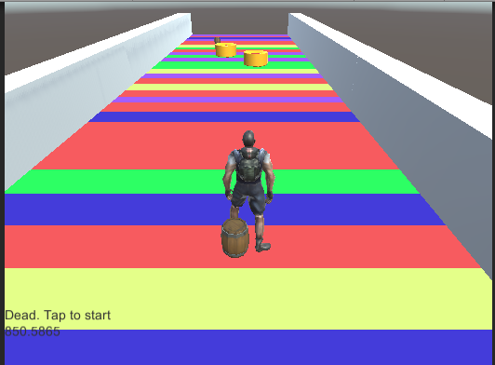

INFINITE RUNNING GAME

INTRODUCTION
Endless Runner is a type of game where the player is constantly moving forward while collecting points and avoiding obstacles
Infinite runners are those games that have the character running forward endlessly and then throw obstacles at them along the way for them to hurdle, punch and dodge. What’s so great about this style of gameplay is that it often only has one input – tap to jump. Because the character runs forward on their own, there is no need for directional control.

STEPS FOR CREATING GAME
First, you need to install and set-up Unity, along with the Android SDK and Java JDK. This is a fairly simple process that involves downloading Unity from Unity3D.com Make sure that you have ticked ‘Android Build Support’ and ‘Microsoft Visual Studio Community 2015’. The latter is the IDE you’ll be using to add the C# code and the former is what will allow us to build APKs
it can also be a good idea to select ‘Standard Assets’, which will give you lots of scripts, 3D models, effects and more that you can play around with and use.
The final thing you’ll need to do, is to make sure that you tell Unity where it can find the SDK. That means going to Edit > Preferences > External Tools and then entering the path into the box next to ‘SDK’. Do the same for the JDK.

Creating basic tiles
First, we’re going to create a platform prefab. This will be a basic block that our character will stand on and that we can then repeat over and over again throughout the level to create our obstacles.
To import the sprite into your Unity project, first create a new folder in your Assets called ‘Sprites’. Right click on the Project window and then choose Create > Folder and name as appropriate.
To move sprites, make sure you have the move tool selected in the top right – this is the second from the left and looks like four arrows. If you find that the sprites are moving too far or not far enough, then go to Edit > Snap Settings and make sure that ‘Move X’ and ‘Move Y’ are set to ‘1’.
Choose Physics 2D > Box Collider 2D and a thin green box should appear around the outside.

Setting the scene

Now before you go pasting those tiles around the level, you’re going to head into the Assets folder again (click ‘Assets’ in the Project Window) and then create another folder called ‘Prefabs’. Now, grab your Turf sprite from the hierarchy on the left – not the Project window – and drag it into that folder.
Now drag all of Turf tiles on top of that GameObject and they will be arranged underneath it. There’s a little arrow next to Tiles on the left and by clicking that you’ll be able to collapse or expand the category. What’s more is that if you move the ‘Tiles’ GameObject around, it will move all of the tiles in relation to its position.
Once the new folder is created, you can hit Ctrl + S and save your work so far as

Adding a playable character

And now with all that done, we can finally add an actual character to our game .To do this, we first need to create a new sprite. So for it I am taking as a human chacter as they are easy to make
You also need to drag the Main Camera in your Hierarchy window onto the Player object Remember how I said earlier that moving the ‘Tiles’ empty GameObject

Gameplay and scripts
create a new folder in assets and call it ‘Scripts’, then open up this folder and use RMB > Create > C# Script and call this script ‘Player’. Double click on your Player script and it should launch Visual Studio for you to add some code.
Unity, select the player prefab from the Prefabs folder, and click Add Component > Scripts > Player through the Inspector. Try hitting ‘Play’ now and you’ll find that the character should simply move forward at a slow pace until he falls off the platform or perhaps bumps into something.

Setting it up for Android
Android makes this super simple. All you need to do is to save the scene and then choose File > Build Settings. Drag the scene you just saved into ‘Scenes in Build’. When you have multiple scenes, the one at the top will be the one that runs first – so this is where your menu page would go in future.

FINAL EXECUTION STEPS
after the game is made and codes have run successfully we will run the game and it will show us an interface where a person is running and in front of him candys are there he needs to collect the candies and after collecting his score gonna increase if that mans touches wood obstacle the game will stop .As this game has two path 1.straight 2. Rotate .

codes

INPUTS
ArrowKeysDetector
using Assets.Scripts;
using UnityEngine;

public class ArrowKeysDetector : MonoBehaviour, IInputDetector
{
public InputDirection? DetectInputDirection()
{
if (Input.GetKeyUp(KeyCode.UpArrow))
return InputDirection.Top;
else if (Input.GetKeyUp(KeyCode.DownArrow))
return InputDirection.Bottom;
else if (Input.GetKeyUp(KeyCode.RightArrow))
return InputDirection.Right;
else if (Input.GetKeyUp(KeyCode.LeftArrow))
return InputDirection.Left;
else
return null;
}
}

IInputDetector
using System;
using System.Collections.Generic;
using System.Linq;
using System.Text;

namespace Assets.Scripts
{
public interface IInputDetector
{
InputDirection? DetectInputDirection();
}

public enum InputDirection
{
Left, Right, Top, Bottom
}
}

SWIPEDETECTOR
using UnityEngine;
using System;
using Assets.Scripts;

public enum State
{
SwipeNotStarted,
SwipeStarted
}

public class SwipeDetector : MonoBehaviour, IInputDetector
{

private State state = State.SwipeNotStarted;
private Vector2 startPoint;
private DateTime timeSwipeStarted;
private TimeSpan maxSwipeDuration = TimeSpan.FromSeconds(1);
private TimeSpan minSwipeDuration = TimeSpan.FromMilliseconds(100);

public InputDirection? DetectInputDirection()
{
if (state == State.SwipeNotStarted)
{
if (Input.GetMouseButtonDown(0))
{
timeSwipeStarted = DateTime.Now;
state = State.SwipeStarted;
startPoint = Input.mousePosition;
}
}
else if (state == State.SwipeStarted)
{
if (Input.GetMouseButtonUp(0))
{
TimeSpan timeDifference = DateTime.Now - timeSwipeStarted;
if (timeDifference <= maxSwipeDuration && timeDifference >= minSwipeDuration)
{
Vector2 mousePosition = Input.mousePosition;
Vector2 differenceVector = mousePosition - startPoint;
float angle = Vector2.Angle(differenceVector, Vector2.right);
Vector3 cross = Vector3.Cross(differenceVector, Vector2.right);

if (cross.z > 0)
angle = 360 - angle;

state = State.SwipeNotStarted;

if ((angle >= 315 && angle < 360) || (angle >= 0 && angle <= 45))
return InputDirection.Right;
else if (angle > 45 && angle <= 135)
return InputDirection.Top;
else if (angle > 135 && angle <= 225)
return InputDirection.Left;
else
return InputDirection.Bottom;
}
}
}
return null;
}

}

CANDY
using UnityEngine;
using System.Collections;
using Assets.Scripts;

public class Candy : MonoBehaviour
{
//candy found in https://www.assetstore.unity3d.com/en/#!/content/12512

// Update is called once per frame
void Update()
{
transform.Rotate(Vector3.up, Time.deltaTime * rotateSpeed);
}

void OnTriggerEnter(Collider col)
{
UIManager.Instance.IncreaseScore(ScorePoints);
Destroy(this.gameObject);
}

public int ScorePoints = 100;
public float rotateSpeed = 50f;
}

CharacterRotateMovement
using UnityEngine;
using Assets.Scripts;
using UnityEngine.SceneManagement;

public class CharacterRotateMovement : MonoBehaviour
{
private Vector3 moveDirection = Vector3.zero;
public float gravity = 20f;
private CharacterController controller;
private Animator anim;

public float JumpSpeed = 8.0f;
public float Speed = 6.0f;
public Transform CharacterGO;

bool isInSwipeArea;

IInputDetector inputDetector = null;

// Use this for initialization
void Start()
{
moveDirection = transform.forward;
moveDirection = transform.TransformDirection(moveDirection);
moveDirection *= Speed;

UIManager.Instance.ResetScore();
UIManager.Instance.SetStatus(Constants.StatusTapToStart);

GameManager.Instance.GameState = GameState.Start;

anim = CharacterGO.GetComponent<Animator>();
inputDetector = GetComponent<IInputDetector>();
controller = GetComponent<CharacterController>();
}

// Update is called once per frame
void Update()
{
switch (GameManager.Instance.GameState)
{
case GameState.Start:
if (Input.GetMouseButtonUp(0))
{
anim.SetBool(Constants.AnimationStarted, true);
var instance = GameManager.Instance;
instance.GameState = GameState.Playing;

UIManager.Instance.SetStatus(string.Empty);
}
break;
case GameState.Playing:
UIManager.Instance.IncreaseScore(0.001f);

CheckHeight();

DetectJumpOrSwipeLeftRight();

//apply gravity
moveDirection.y -= gravity * Time.deltaTime;
//move the player
controller.Move(moveDirection * Time.deltaTime);

break;
case GameState.Dead:
anim.SetBool(Constants.AnimationStarted, false);
if (Input.GetMouseButtonUp(0))
{
//restart
SceneManager.LoadScene(SceneManager.GetActiveScene().buildIndex);
}
break;
default:
break;
}

}

private void CheckHeight()
{
if (transform.position.y < -10)
{
GameManager.Instance.Die();
}
}

private void DetectJumpOrSwipeLeftRight()
{
var inputDirection = inputDetector.DetectInputDirection();
if (controller.isGrounded && inputDirection.HasValue && inputDirection == InputDirection.Top)
{
moveDirection.y = JumpSpeed;
anim.SetBool(Constants.AnimationJump, true);
}
else
{
anim.SetBool(Constants.AnimationJump, false);
}

if (GameManager.Instance.CanSwipe && inputDirection.HasValue &&
controller.isGrounded && inputDirection == InputDirection.Right)
{
transform.Rotate(0, 90, 0);
moveDirection = Quaternion.AngleAxis(90, Vector3.up) * moveDirection;
//allow the user to swipe once per swipe location
GameManager.Instance.CanSwipe = false;
}
else if (GameManager.Instance.CanSwipe && inputDirection.HasValue &&
controller.isGrounded && inputDirection == InputDirection.Left)
{
transform.Rotate(0, -90, 0);
moveDirection = Quaternion.AngleAxis(-90, Vector3.up) * moveDirection;
GameManager.Instance.CanSwipe = false;
}

}

}

CharacterSidewaysMovement

using UnityEngine;
using Assets.Scripts;
using UnityEngine.SceneManagement;
using System.Collections;

public class CharacterSidewaysMovement : MonoBehaviour
{

private Vector3 moveDirection = Vector3.zero;
public float gravity = 20f;
private CharacterController controller;
private Animator anim;

private bool isChangingLane = false;
private Vector3 locationAfterChangingLane;
//distance character will move sideways
private Vector3 sidewaysMovementDistance = Vector3.right * 2f;

public float SideWaysSpeed = 5.0f;

public float JumpSpeed = 8.0f;
public float Speed = 6.0f;
//Max gameobject
public Transform CharacterGO;

IInputDetector inputDetector = null;

// Use this for initialization
void Start()
{
moveDirection = transform.forward;
moveDirection = transform.TransformDirection(moveDirection);
moveDirection *= Speed;

UIManager.Instance.ResetScore();
UIManager.Instance.SetStatus(Constants.StatusTapToStart);

GameManager.Instance.GameState = GameState.Start;

anim = CharacterGO.GetComponent<Animator>();
inputDetector = GetComponent<IInputDetector>();
controller = GetComponent<CharacterController>();
}

// Update is called once per frame
void Update()
{
switch (GameManager.Instance.GameState)
{
case GameState.Start:
if (Input.GetMouseButtonUp(0))
{
anim.SetBool(Constants.AnimationStarted, true);
var instance = GameManager.Instance;
instance.GameState = GameState.Playing;

UIManager.Instance.SetStatus(string.Empty);
}
break;
case GameState.Playing:
UIManager.Instance.IncreaseScore(0.001f);

CheckHeight();

DetectJumpOrSwipeLeftRight();

//apply gravity
moveDirection.y -= gravity * Time.deltaTime;

if (isChangingLane)
{
if (Mathf.Abs(transform.position.x - locationAfterChangingLane.x) < 0.1f)
{
isChangingLane = false;
moveDirection.x = 0;
}
}

//move the player
controller.Move(moveDirection * Time.deltaTime);

break;
case GameState.Dead:
anim.SetBool(Constants.AnimationStarted, false);
if (Input.GetMouseButtonUp(0))
{
//restart
SceneManager.LoadScene(SceneManager.GetActiveScene().buildIndex);
}
break;
default:
break;
}

}

private void CheckHeight()
{
if (transform.position.y < -10)
{
GameManager.Instance.Die();
}
}

private void DetectJumpOrSwipeLeftRight()
{
var inputDirection = inputDetector.DetectInputDirection();
if (controller.isGrounded && inputDirection.HasValue && inputDirection == InputDirection.Top
&& !isChangingLane)
{
moveDirection.y = JumpSpeed;
anim.SetBool(Constants.AnimationJump, true);
}
else
{
anim.SetBool(Constants.AnimationJump, false);
}

if (controller.isGrounded && inputDirection.HasValue && !isChangingLane)
{
isChangingLane = true;

if (inputDirection == InputDirection.Left)
{
locationAfterChangingLane = transform.position - sidewaysMovementDistance;
moveDirection.x = -SideWaysSpeed;
}
else if (inputDirection == InputDirection.Right)
{
locationAfterChangingLane = transform.position + sidewaysMovementDistance;
moveDirection.x = SideWaysSpeed;
}
}

}

public void OnControllerColliderHit(ControllerColliderHit hit)
{
//if we hit the left or right border
if(hit.gameObject.tag == Constants.WidePathBorderTag)
{
isChangingLane = false;
moveDirection.x = 0;
}
}

}

CONSTANTS
/// <summary>
/// Helpful constants
/// </summary>
public static class Constants
{
public static readonly string PlayerTag = "Player";
public static readonly string AnimationStarted = "started";
public static readonly string AnimationJump = "jump";
public static readonly string WidePathBorderTag = "WidePathBorder";

/// <summary>
/// some UI text
/// </summary>
public static readonly string StatusTapToStart = "Tap to start";
public static readonly string StatusDeadTapToStart = "Dead. Tap to start";
}

GameManager
using System;
using System.Collections.Generic;
using System.Linq;
using System.Text;
using UnityEngine;

public class GameManager : MonoBehaviour
{
void Awake()
{
if (instance == null)
{
instance = this;
}
else
{
DestroyImmediate(this);
}
}

private static GameManager instance;
public static GameManager Instance
{
get
{
if (instance == null)
{
instance = new GameManager();
}
return instance;
}
}

protected GameManager()
{
GameState = GameState.Start;
CanSwipe = false;
}

public GameState GameState { get; set; }

public bool CanSwipe { get; set; }

public void Die()
{
UIManager.Instance.SetStatus(Constants.StatusDeadTapToStart);
this.GameState = GameState.Dead;
}

}

STARTING OF GAME
/// <summary>
/// Our game state enum
/// </summary>
public enum GameState
{
Start,
Playing,
Dead
}

IntroLevel
using UnityEngine;
using System.Collections;
using UnityEngine.SceneManagement;

public class IntroLevel : MonoBehaviour {

public void StraightLevelClick()
{
SceneManager.LoadScene("straightPathsLevel");
}

public void RotatedLevelClick()
{
SceneManager.LoadScene("rotatedPathsLevel");
}
}

Obstacle
using UnityEngine;
using System.Collections;
using Assets.Scripts;

public class Obstacle : MonoBehaviour {

//box and barrel found here: https://www.assetstore.unity3d.com/en/#!/content/11256

void OnTriggerEnter(Collider col)
{
//if the player hits one obstacle, it's game over
if(col.gameObject.tag == Constants.PlayerTag)
{
GameManager.Instance.Die();
}
}
}

PathSpawnCollider
using UnityEngine;
using System.Collections;

public class PathSpawnCollider : MonoBehaviour {

public float positionY = 0.81f;
public Transform[] PathSpawnPoints;
public GameObject Path;
public GameObject DangerousBorder;

void OnTriggerEnter(Collider hit)
{
//player has hit the collider
if (hit.gameObject.tag == Constants.PlayerTag)
{
//find whether the next path will be straight, left or right
int randomSpawnPoint = Random.Range(0, PathSpawnPoints.Length);
for (int i = 0; i < PathSpawnPoints.Length; i++)
{
//instantiate the path, on the set rotation
if (i == randomSpawnPoint)
Instantiate(Path, PathSpawnPoints[i].position, PathSpawnPoints[i].rotation);
else
{
//instantiate the border, but rotate it 90 degrees first
Vector3 rotation = PathSpawnPoints[i].rotation.eulerAngles;
rotation.y += 90;
Vector3 position = PathSpawnPoints[i].position;
position.y += positionY;
Instantiate(DangerousBorder, position, Quaternion.Euler(rotation));
}
}

}
}

}

RandomMaterial
using UnityEngine;
using System.Collections;

public class RandomMaterial : MonoBehaviour {

// Use this for initialization
void Awake () {
GetComponent<Renderer>().material = GetRandomMaterial();
}

/// <summary>
/// helper method to get a random color
/// </summary>
/// <returns></returns>
public Material GetRandomMaterial()
{
int x = Random.Range(0, 5);
if (x == 0)
return Resources.Load("Materials/redMaterial") as Material;
else if (x == 1)
return Resources.Load("Materials/greenMaterial") as Material;
else if (x == 2)
return Resources.Load("Materials/blueMaterial") as Material;
else if (x == 3)
return Resources.Load("Materials/yellowMaterial") as Material;
else if (x == 4)
return Resources.Load("Materials/purpleMaterial") as Material;
else
return Resources.Load("Materials/redMaterial") as Material;
}

}

RedBorder
using UnityEngine;
using System.Collections;

public class RedBorder : MonoBehaviour
{

// Use this for initialization
void OnTriggerEnter(Collider col)
{
if (col.gameObject.tag == Constants.PlayerTag)
GameManager.Instance.Die();
}
}

StuffSpawner
using UnityEngine;
using System.Collections;

public class StuffSpawner : MonoBehaviour
{
//points where stuff will spawn :)
public Transform[] StuffSpawnPoints;
//meat gameobjects
public GameObject[] Bonus;
//obstacle gameobjects
public GameObject[] Obstacles;

public bool RandomX = false;
public float minX = -2f, maxX = 2f;

// Use this for initialization
void Start()
{
//first, let's decide whether we'll place an obstacle
//beware, Random.Range is exclusive for integers but inclusive for floats
//http://answers.unity3d.com/questions/585266/question-about-randomrange.html
bool placeObstacle = Random.Range(0, 2) == 0; //50% chances
int obstacleIndex = -1;
if (placeObstacle)
{
//select a random spawn point, apart from the first one
//since we do not want an obstacle there
obstacleIndex = Random.Range(1, StuffSpawnPoints.Length);

CreateObject(StuffSpawnPoints[obstacleIndex].position, Obstacles[Random.Range(0, Obstacles.Length)]);
}

for (int i = 0; i < StuffSpawnPoints.Length; i++)
{
//don't instantiate if there's an obstacle
if (i == obstacleIndex) continue;
if (Random.Range(0, 3) == 0) //33% chances to create candy
{
CreateObject(StuffSpawnPoints[i].position, Bonus[Random.Range(0, Bonus.Length)]);
}
}

}

void CreateObject(Vector3 position, GameObject prefab)
{
if (RandomX) //true on the wide path, false on the rotated ones
position += new Vector3(Random.Range(minX, maxX), 0, 0);

Instantiate(prefab, position, Quaternion.identity);
}

}

SwipeCollider

using UnityEngine;
using System.Collections;

public class SwipeCollider : MonoBehaviour
{

// Use this for initialization
void OnTriggerEnter(Collider hit)
{
if (hit.gameObject.tag == Constants.PlayerTag)
GameManager.Instance.CanSwipe = true;
}

void OnTriggerExit(Collider hit)
{
if (hit.gameObject.tag == Constants.PlayerTag)
GameManager.Instance.CanSwipe = false;
}
}

TimeDestroyer
using UnityEngine;
using System.Collections;

public class TimeDestroyer : MonoBehaviour
{

// Use this for initialization
void Start()
{
Invoke("DestroyObject", LifeTime);
}

void DestroyObject()
{
if (GameManager.Instance.GameState != GameState.Dead)
Destroy(gameObject);
}

public float LifeTime = 10f;
}

UIManager
using UnityEngine;
using System.Collections;
using UnityEngine.UI;

public class UIManager : MonoBehaviour
{

void Awake()
{
if (instance == null)
{
instance = this;
}
else
{
DestroyImmediate(this);
}
}

//singleton implementation
private static UIManager instance;
public static UIManager Instance
{
get
{
if (instance == null)
instance = new UIManager();

return instance;
}
}

protected UIManager()
{
}

private float score = 0;

public void ResetScore()
{
score = 0;
UpdateScoreText();
}

public void SetScore(float value)
{
score = value;
UpdateScoreText();
}

public void IncreaseScore(float value)
{
score += value;
UpdateScoreText();
}

private void UpdateScoreText()
{
ScoreText.text = score.ToString();
}

public void SetStatus(string text)
{
StatusText.text = text;
}

public Text ScoreText, StatusText;

}

OUTPUT

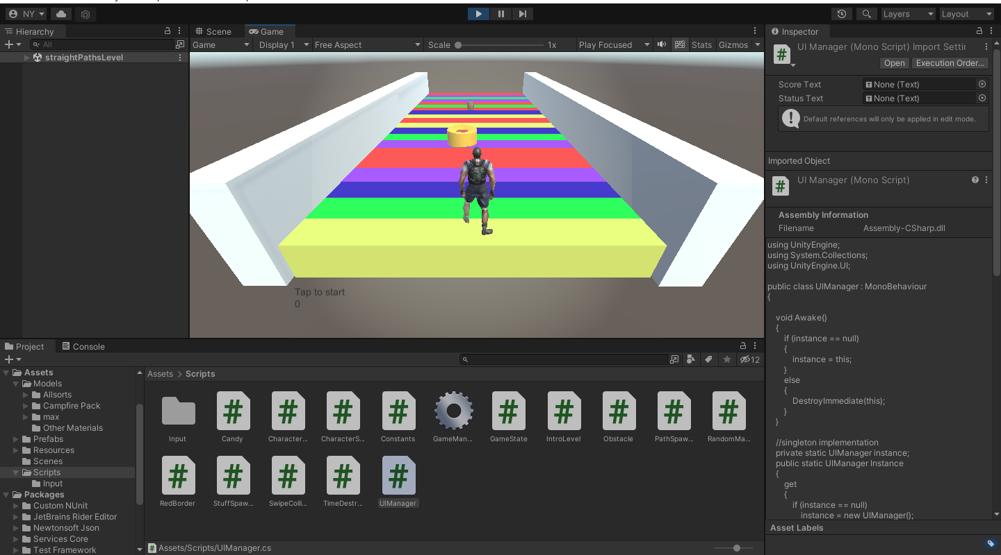

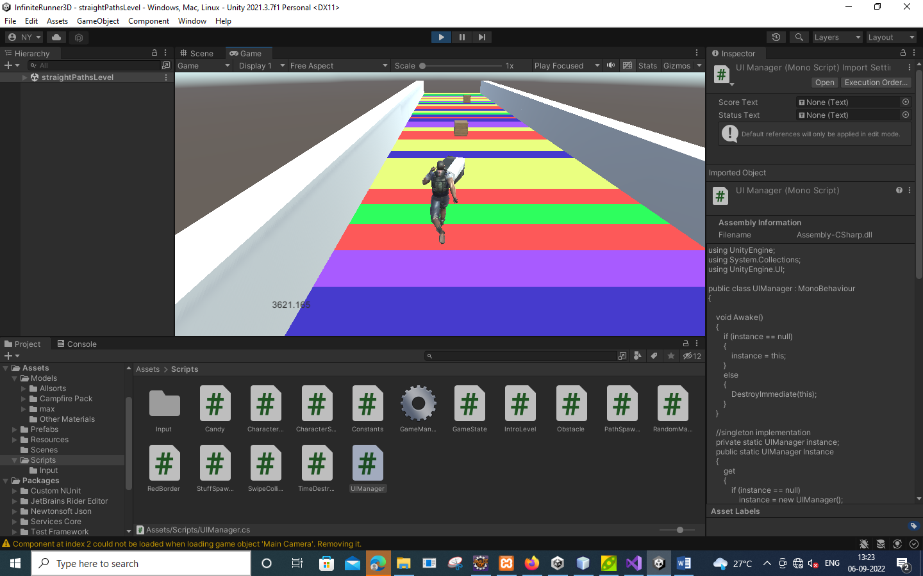
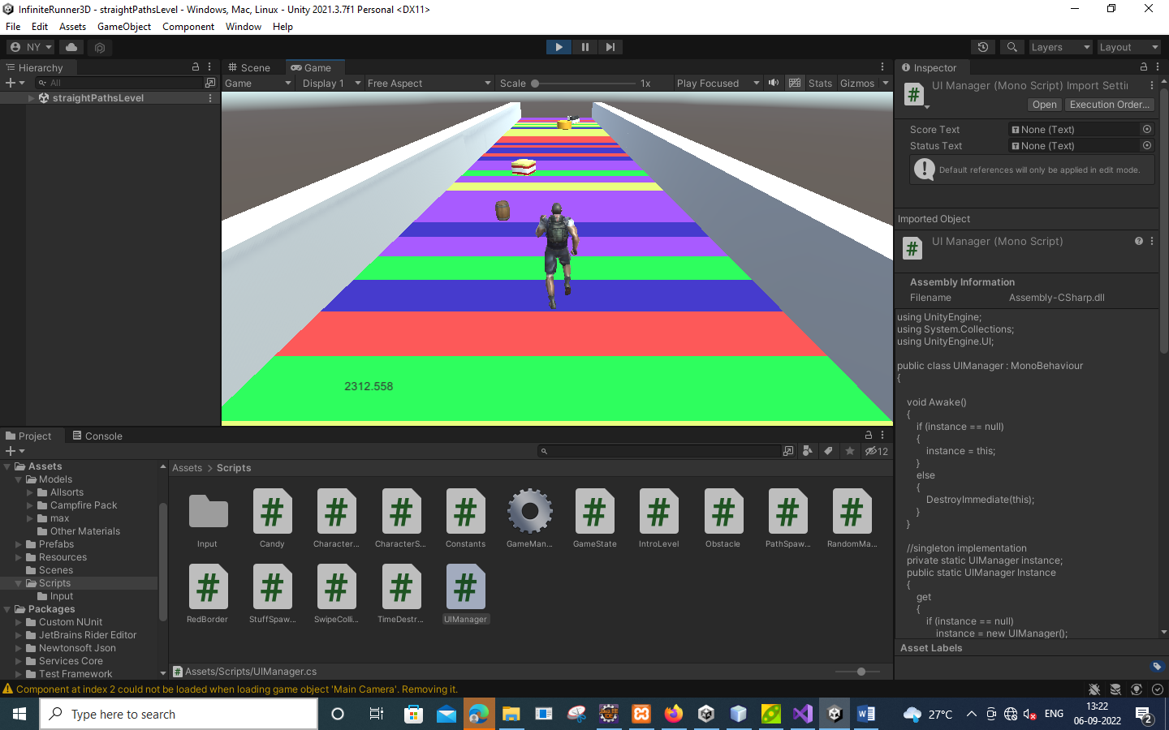

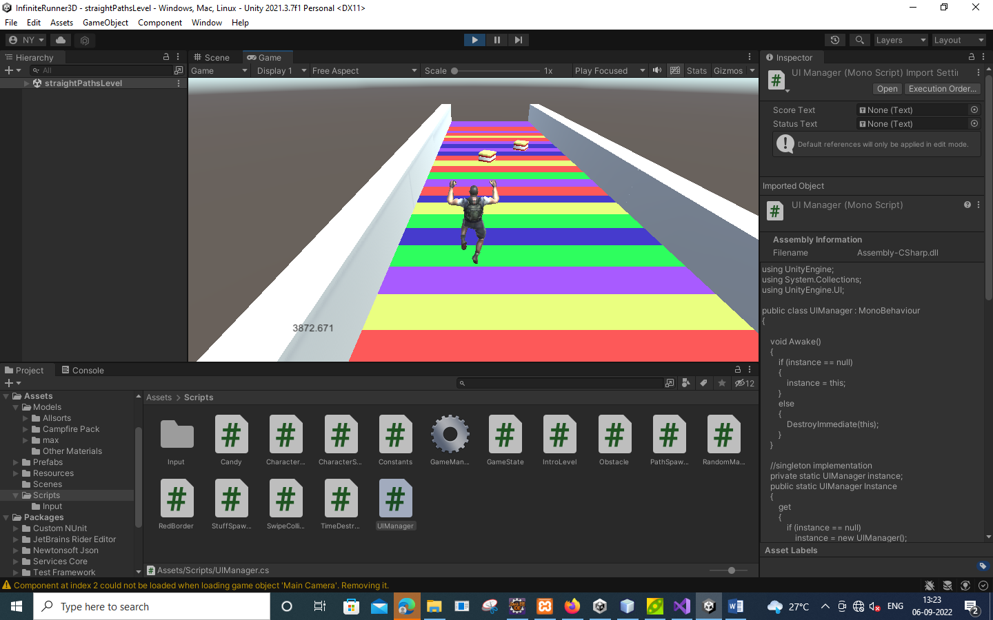

VIDEO OF GAME



Drive link:
https://drive.google.com/drive/u/0/folders/14G5kkFaSQElUjLBboLPtsO9mQcztnpUf

